
Student Ambassador Leadership Team
A student-centered opportunity for leadership, service, professional growth,
and college representation

The UBTech Student Ambassador Leadership Team empowers students to represent the College with pride while developing leadership abilities, building professional networks, serving their communities, and preparing for success beyond graduation.

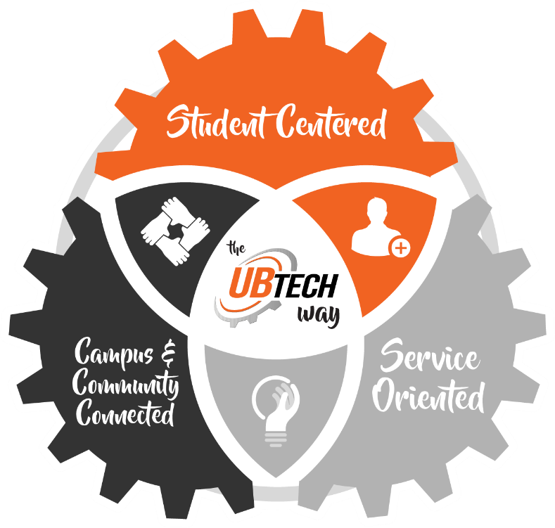

Rooted in the UBTech Way, we place students at the center of all we do, building meaningful relationships, strengthening connections between campus and community, and serving others through collaboration, respect, and support.

Through campus events, outreach, recruitment, professional development, and community service, students earn points and advance through four leadership levels. As ambassadors progress, they gain increased responsibility, recognition, mentorship, and career-development opportunities.
Ambassador Expectations
As representatives of UBTech, ambassadors are expected to:
- Be currently enrolled at UBTech.
- Maintain good academic standing and demonstrate steady progress in their education.
- Remain free of academic or conduct sanctions that would prevent appropriate representation of the college.
- Be respectful, reliable, supportive, and professional in all interactions.
- Attend required monthly training, orientation sessions, and assigned ambassador activities.
- Communicate promptly when unable to attend scheduled events or when academic or personal circumstances may affect participation.
- Complete assigned responsibilities and follow through on commitments.
- Wear ambassador attire when representing the college.
- Speak positively, respectfully, and accurately about UBTech.
- Maintain professional conduct in person, online, and on social media.
- Refer questions outside their knowledge to the appropriate UBTech employee.
- Demonstrate readiness for increased responsibility as they advance through the leadership levels.
If a student is not meeting expectations related to academics, attendance, conduct, communication, reliability, or assigned responsibilities, the Ambassador Team may review the student's participation and determine whether continued involvement is appropriate. Participation in the Ambassador Team is separate from academic enrollment at UBTech, and removal from the Ambassador Team does not impact a student's ability to continue their education or complete their training program.

Ambassador Portfolio
Throughout the program, ambassadors build a professional portfolio that showcases their leadership, service, involvement, and career-ready skills. Portfolio materials may include a professional headshot, biography, resume, event participation record, leadership experiences, letters of recommendation, awards, and other accomplishments that highlight their growth and achievements.

Ambassador Support
Each ambassador is paired with an Outreach Specialist who provides goal-setting support, guidance, and connection throughout the student’s ambassador experience.
Ambassador Leadership Levels
Students progress through four leadership levels. Each level reflects increased participation, professional growth, service, and responsibility. Reaching the minimum point total makes a student eligible for the next level; advancement also requires meeting program expectations and demonstrating readiness for the responsibilities of that level.
Level | Points | Primary Emphasis
Level 1: Student Ambassador | 0-29 | Orientation, engagement, connection, and foundational professional skills
Level 2: Lead Ambassador | 30-59 | Skill development, professional branding, and increased event responsibility
Level 3: Senior Ambassador | 60-79 | Leadership, mentorship, team coordination, industry connection, and College recognition
Level 4: Presidential Ambassador | 80+ | Graduation recognition, recommendation letters, exclusive events

Ambassador Point System
Points recognize participation and contribution. Activities involving greater preparation, public representation, leadership, or mentoring receive more points.
Activity | Points
Attend Ambassador Orientation | 10
Participate in a Campus Tour | 10
Attend an Industry Networking Event | 10
Attend an Ambassador Leadership Meeting | 10
Participate in a Secondary School Event | 15
Help with an Ambassador Campaign | 15
Participate in a Community Outreach Event | 15
Complete a Community Volunteer Activity | 15
Complete a Workforce Promise Activity | 15
Speak at an Event | 25
Lead an Event Activity | 25
Mentor a New Ambassador | 25
Create a Social Media Video Highlighting a UBTech Program | 25
Level 1: Student Ambassador | 0-29 Points
Focus: Learning, Engagement, and Connection
Recognition and Rewards:
- Ambassador T-shirt
- Ambassador tumbler
- Free drink punch card for Tek's
- Ambassador name badge
- Goal-setting worksheet
- Assignment to an Outreach Specialist for goal-setting, guidance, and connection
Professional Development: Ambassadors build confidence and career-ready skills through training in public speaking, communication, and workplace professionalism.

Level 2: Lead Ambassador | 30-59 Points
Focus: Skill Development and Professional Branding
Recognition and Rewards:
- UBTech-branded hoodie or quarter-zip
- Professional headshot session
- Ambassador wall recognition
Professional Development: As Lead Ambassadors, students build leadership, communication, networking, and career-readiness skills while taking on greater responsibility at ambassador events. Through hands-on experience supporting event coordination, training, and student engagement, ambassadors strengthen their confidence, professionalism, and ability to represent UBTech both on campus and in the community.

Level 3: Senior Ambassador | 60-79 Points
Focus: Professional Growth, Leadership, and Mentorship
Recognition and Rewards:
- Personalized Ambassador jacket
- Industry/Alumni connections and possible mentorship
- Introductions to employers and industry leaders
- Recognition with UBTech leadership
- Ambassador Spotlight opportunity
Professional Development: Senior Ambassadors take an active leadership role by leading campus tours, mentoring new ambassadors, coordinating ambassador activities, and helping support and organize Ambassador Program events. Through these experiences, students strengthen their leadership, teamwork, and mentoring skills while serving as role models for other ambassadors.
Level 4: Presidential Ambassador | 80+ Points
Focus: Career Readiness and Institutional Leadership

Recognition and Rewards:
- Opportunity to interview with the College President
- Consideration for a personalized letter of recommendation from the College President following the interview and review of the student’s academic performance, leadership, service, and overall participation in the Ambassador Program
- Invitation to the Presidential Leadership Breakfast
- Special graduation recognition
Professional Development: Presidential Ambassadors serve as UBTech's highest student representatives, helping strengthen connections between students, the college, industry, and the community.

